**UNIT-II**

**ELECTRIC HEATING**

# ELECTRIC HEATING

# It is a process in which electrical energy is converted to heat. Heating is required for both industrial and domestic purposes.

# In industries, heating is required for the melting of metals, moulding of glass, enamelling of copper, baking of insulator and welding etc.

# In domestic purposes the heating is required for cooking, water heating, room heating in winter, pressing clothes and many more.

# ADVANTAGES OF ELECTRIC HEATING

# a)Economical: Electric heating equipment is cheaper; they do not require much skilled persons; therefore, maintenance cost is less.

# b)Cleanliness: Since dust and ash are completely eliminated in the electric heating, it keeps surroundings clean.

# c)Pollution free: As there are no flue gases in the electric heating, atmosphere around is pollution free; no need of providing space for their exit.

# d)Ease of control: In this heating, temperature can be controlled and regulated accurately either manually or automatically.

# (e)Uniform heating: The substance can be heated uniformly throughout whether it may be conducting or non-conducting material.

# (f)High efficiency: In non-electric heating, only 40-60% of heat is utilized but in electric heating 75-100% of heat can be successfully utilized. So, overall efficiency of electric heating is very high.

# (g)Automatic protection: Protection against over current and overheating can be provided by using control devices.

# (h)Heating of non-conducting materials: The heat developed in the non-conducting materials such as wood and porcelain is possible only through the electric heating.

# (i)Better working conditions: No irritating noise is produced with electric heating and also radiating losses are low.

# (j)Less floor area: Due to the compactness of electric furnace, floor area required is less.

# (k)High temperature: High temperature can be obtained by the electric heating except the ability of the material to withstand the heat.

# MODES OF TRANSFER OF HEAT

The transmission of the heat energy from one body to another because of the temperature gradient takes place by any of the following methods:

### Conduction

One molecule of substance gets heated and transfers the heat to the adjacent one and so on.

In this mode, the heat transfers from one part of substance to another part without the movement in the molecules of substance. The rate of the conduction of heat along the substance depends upon the temperature gradient may be expressed in *[MJ/h/m2/m] or[W/cm2/cm]*

*t*=Plat thickness in *m*

*A*=X-sectional area of its two parallel face in *m2*

*T1 & T2*=Temperature of two face in *°C*

*T*=duration of heat transfer in *hr*

*K*=Co-efficient of thermal conductivity for the material in *MJ/m2/m/°C/hr*

**

Ex: Refractory heating, the heating of insulating materials, etc.

### Convection

In this mode, the heat transfer takes place from one part to another part of substance or fluid due to the actual motion of the molecules. The rate of heat depends mainly on the difference in the fluid density at different temperatures.

The quantity of heat absorbed from the heater by convection are depends on temperature of the heating element above the surrounding, size of surface of heater, on the position of heater.

Heat dissipated,

*H=a(T1-T2)b in W/m2*

*a & b* are constant (depends on heating surface)

*T1 & T2* are the temperature of the heating surface and fluid in *°C*

Ex: Immersion water heater.

### Radiation

In this mode, the heat transfers from source to the substance to be heated without heating the medium in between. It is dependent on surface.

Rate of heat radiation is given by Stefan’s law. Heat dissipation is given by

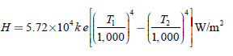

Where,

*T1*=Temperature of source of heat in *°C*

*T2*= Temperature of substance to be heated in *°C*

*K*=Constant known as radiant efficiency

*e*=emissivity

Ex: Solar heaters.

**DESIGN OF HEATING ELEMENTS:**

By knowing the voltage and electrical energy input, the design of the heating element for an electric furnace is required to determine the size and length of the heating element. The wire employed may be circular or rectangular like a ribbon. The ribbon-type heating element permits the use of higher wattage per unit area compared to the circular-type element.

***Circular-type heating element***

Initially when the heating element is connected to the supply, the temperature goes on increasing and finally reaches high temperature.

Let *V* be the supply voltage of the system and *R* be the resistance of the element, then electric power input, .

Image

If *ρ* is the resistivity of the element, *l* is the length, ‘*a*’ is the area, and *d* is the diameter of the element, then:

Image

Therefore, power input,



By rearranging the above equation, we get:



where ,

*P* is the electrical power input per phase (watt),

*V* is the operating voltage per phase (volts),

*R* is the resistance of the element (Ω),

*l* is the length of the element (*m*),

*a* is the area of cross-section (m2),

*d* is the diameter of the element (*m*), and

*ρ* is the specific resistance (Ω-m)

According to Stefan's law, heat dissipated per unit area is

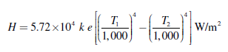

where *T*1 is the absolute temperature of the element (K),

*T*2 is the absolute temperature of the charge (K),

*e* is the emissivity, and

*k* is the radiant efficiency.

The surface area of the circular heating element:

*S* = *πdl.*

∴ Total heat dissipated = surface area × *H*

                           = *Hπdl*.

Under thermal equilibrium,

Power input = heat dissipated

*P* = *H* × *πdl*.

Substituting *P* from Equation in above equation:

Image



By solving the above Equations the length and diameter of the wire can be determined.

***Ribbon-type element***

Let ‘*w*’ be the width and ‘*t*’ be the thickness of the ribbon-type heating element.



We know that, Image (for ribbon or rectangular element, *a* = *w* × *t*)

Image



The surface area of the rectangular element (*S*) = 2 *l* ×*w*.

∴ Total heat dissipated = *H* × *S*

= *H* × 2 *lw.*

∴Under the thermal equilibrium,

Electrical power input = heat dissipated

*P* = *H* × 2 *lw*



By solving the above Equations the length and width of the heating element can be determined.

# Classification of electric heating method:

**Electrical Heating**



**Power Frequency Heating High Frequency Heating**



**Resistance**

**Heating**

**Arc Heating Electron Bombardment**

**Heating**



**Induction**

**Heating**



**Dielectric**

**Heating**

**Direct Resistance Heating**

**Direct Arc Heating**

**Indirect Resistance Heating**

**Indirect Arc Heating**

**Radiant (or) Infrared Heating**

**Direct Induction Heating**

**Indirect Induction Heating**

# RESISTANCE HEATING

When current passes through a resistance, Power loss takes place there in which appears in the form of heat,

Electrical energy converted into heat energy

*H = I2Rt*

Power loss = *I2R Watts*

= *VI Watts*

= *V2/R Watts*

Where,

*R*=Resistance of the element (*Ω*)

*V*=Voltage (*Volt*)

*I*=Current (*ampere*)

### Direct Resistance Heating

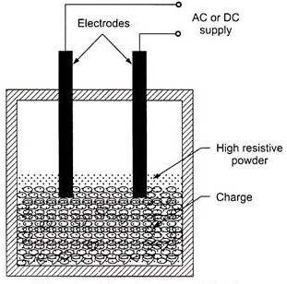

1. In this method, electrodes are immersed in a material or charge to be heated.The charge may be in the form of powder, pieces or liquid.The electrodes are connected to AC or DC supply.
2. In case of DC or 1-Φ AC, two electrodes are immersed and three electrodes are immersed in the charge and connected to supply in case of availability of 3- Φ supply.

When metal pieces are to be heated, the powder of highly resistive is sprinkled over the surface of the charge (or) pieces to avoid direct short circuit between electrodes.

1. The current flows through the charge and heat is produced in the charge itself. So, this method has high efficiency.

As the current in this case is not variable, so that automatic temperature control is not possible.

This method of heating is employed in salt bath furnace and electrode boiler for heating water.

***(i) Salt bath furnace***

This type of furnace consists of a bath and containing some salt such as molten sodium chloride and two electrodes immersed in it.

Such salt have a fusing point of about 1,000–1,500°C depending upon the type of salt used. When the current is passed between the electrodes immersed in the salt, heat is developed and the temperature of the salt bath may be increased. Such an arrangement is known as a salt bath furnace.

In this bath, the material or job to be heated is dipped. The electrodes should be carefully immersed in the bath in such a way that the current flows through the salt and not through the job being heated. As DC will cause electrolysis so, low-voltage AC up to 20 V and current up to 3,000 A is adopted depending upon the type of furnaces.

The resistance of the salt decreases with increase in the temperature of the salt, therefore, in order to maintain the constant power input, the voltage can be controlled by providing a tap changing transformer. The control of power input is also affected by varying the depth of immersion and the distance between the electrodes.

***(ii) Electrode boiler***

It is used to heat the water by immersing three electrodes in a tank as shown Fig. This is based on the principle that when the electric current passed through the water produces heat due to the resistance offered by it. For DC supply, it results in a lot of evolution of H2 at negative electrode and O2 at positive electrode. Whereas AC supply hardly results in any evolution of gas, but heats the water. Electrode boiler tank is earthed solidly and connected to the ground. A circuit breaker is usually incorporated to make and break all poles simultaneously and an over current protective device is provided in each conductor feeding an electrode.

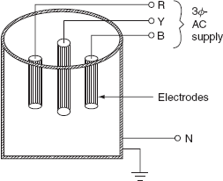

### Indirect Resistance Heating

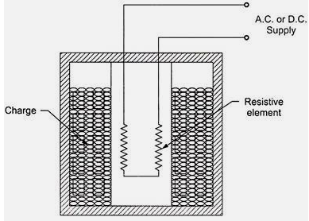

1. In this method of heating, electric current is passed through a wire or other high resistance material forming a heating element.
2. The heat proportional to I2R loss produced in the heating element is delivered to the charge by one or more of the modes of transfer of heat i.e. convection and radiation.
3. An enclosure known as heating chamber is required for heat transfer by radiation and convection for the charge.
4. For industrial purposes, where a large amount of charge is to be heated then the heating element is kept in a cylinder surrounded by jacket containing the charge.
5. The arrangement provides as uniform temperature, automatic temperature control can be provided.
6. Both A.C and D.C supplies can be used for this purpose at full mains voltage depending upon the design of heating element.

# Temperature control of resistance furnaces/ovens.

* + 1. Temperature control is necessary in resistance oven/furnaces – temperature may have to be kept constant or varied according to requirements.
    2. Control may be manual or automatic.
    3. In this heating heat developed depends upon *I2Rt* or *V2t/R*.
    4. **So there are three ways in which the temperature can be controlled:**

### By varying the applied voltage to the elements or current flowing through the element

* 1. Voltage across the oven can be controlled by changing the transformer tapping. This is economical and most suitable if the transformer is to be used for stepping down the voltage for the supply to ovens or furnaces, but such conditions do not arise usually.
  2. Auto-transformer or induction regulator can also be

1. used for variable voltage supply.
   1. Alternative voltage across the oven or furnace can be controlled by varying the impedance connected in series with the circuit. But this method is not economical as
2. power is continuously wasted in the controlling resistance. Therefore limited to small furnaces.

### By varying the resistance of elements

1. Temperature can also be controlled by switching the various combinations of group of resistance used in the ovens or furnaces in the following ways.

### Use of variable number of element

* 1. In this method, the number of heating elements in working is changed; so total power input or heat developed is changed.
  2. This method does not provide uniform heating unless the number of heating elements in the circuit at any particular instant is distributed over the surface area, which requires complicated wiring.

### Change of connections

* 1. In this method the elements are arranged to be connected either all in series or all in parallel or combination of both star or in delta by means of switching at different instant according to the requirements. This is the simplest and most commonly used method of control.

### By varying the ratio of on and off times of supply

1. An on-off switch can also be employed for temperature control but its use is restricted to small ovens.
2. The time duration for which the oven is connected to the supply and the time duration for which it remains cut-off from the supply will determine the temperature.
3. Here an oven is supplied through a thermostat switch which makes and breaks the supply connections at particular temperature.
4. The ratio of time duration during which supply remains on to total time duration of an on-off cycle is an indication of temperature.
5. The higher the ratio, the larger will be the temperature of the oven. Advantages of this method is that it is more efficient then series impedance method.

# ESSENTIAL REQUIREMENTS OF GOOD RESISTANCE HEATING ELEMENT:

1. The materials used for heating element should have the following properties:

**High-specific resistance**: Material should have high-specific resistance so that small length of wire may be required to provide given amount of heat.

1. Ex: Nichrome, a non-magnetic 80/20 alloy of nickel and chromium

**High-melting point:** It should have high-melting point so that it can withstand for high temperature, a small increase in temperature will not destroy the element.

1. Ex: tungsten, at 3,414 °C

**Low temperature coefficient of resistance:** the radiant heat is proportional to fourth powers of the temperatures; it is very efficient heating at high temperature. For accurate temperature control, the variation of resistance with the operating temperature should be very low. This can be obtained only if the material has low temperature coefficient of resistance.

Ex: Semiconductor materials (carbon, silicon, germanium) typically have negative temperature coefficients of resistance**.**

**Free from oxidation:** The element material should not be oxidized when it is subjected to high temperatures; otherwise the formation of oxidized layers will shorten its life.

1. Ex: nichrome 80/20

**High-mechanical strength:** The material should have high-mechanical strength and should withstand for mechanical vibrations.

1. Ex: nichrome 80/20

**Non-corrosive:** The element should not corrode when exposed to atmosphere or any other chemical fumes.

1. Ex: nichrome 80/20

**Economical:** The cost of material should not be so high.

1. Ex: Nickel-based materials and Iron-based materials.

# CAUSES OF FAILURE OF HEATING ELEMENTS:

### Formation of hot spot

* 1. The filament may break where it shines brightest during its operation that means the temperature at the particular spot is higher compared to rest of the filament. This is called formation of the hot spots. It may be created due to following causes:
  2. Unequal spacing: If spacing between the heating element is non-uniform then the temperature will be maximum where spacing is minimum and thus hot spot may be formed.
  3. Supporting Structure: If supporting structure is a bad conductor of heat then it will not transfer any heat, hence temperature of the heating element will be higher near the supports resulting in formation of hot spots.

### Oxidation

The outer surface of the heating element which is open to atmosphere gets oxidized due to higher temperatures.

During switching operation the oxide layer gets flicked off and due to this the inner surface is now open to atmosphere.

### Embrittlement due to gain growth

All heating alloys containing iron tend to form large brittle grains at high temperatures.

When cold, the heating elements are very brittle and liable to rupture easily on slightest handling and jerks.

### Corrosion

Chemical fumes produced during industrial operations corrode the surface of the heating element where the actual contact of fumes with the heating element occurs.

Due to this failure of the heating element occurs.

### Mechanical Failure

During alloying, apportion of the heating element may have a higher content of higher resistivity material so this portion will produce more amount of heat for the same current. Thus, the heating element may be damaged.

# ARC HEATING

1. The heating of matter by an electric arc. The matter may be solid, liquid, or gaseous. When the heating is direct, the material to be heated is one electrode; for indirect heating, the heat is transferred from the arc by convection, or radiation.
2. **ELECTRODES USED IN ARC FURNACES:**
3. **Carbon electrodes**
   1. They are made of anthracite coal and coke.
   2. Cheaper.
   3. Uniform heating can be obtained with large area of carbon electrodes.
   4. Oxidation starts at about 400°C.
   5. Used in small furnaces.
   6. Used in manufacturing of Ferro-alloys, aluminum, calcium carbide, phosphorus.
4. **Graphite electrodes**
   1. They are obtained by heating carbon electrodes to a very high temperature.
   2. Owing to lower resistivity of graphite (one fourth of the carbon), graphite is required half in size for the same current resulting is easy replacement.
   3. Oxidation starts at about 600°C.

**Self - baking electrodes**

(The **electrode** comprises an outer casing made from an electrical conducting material, and having inner radial, vertical ribs. Carbonaceous unbaked **paste** is supplied to the casing, which **paste** is being **baked** to a solid **electrode** by means of electric current supplied to the **electrode)**

* 1. They are made of a special paste, the composition of the paste depends upon the type of process for which it is employed.
  2. When current is passed, heat is produced that bakes the paste to form an electrode.
  3. Used production of Ferro-alloys, electro- chemical furnaces and in production of aluminum by electrolytic process.

**TYPES OF ARC HEATING FURNACES:**

### Direct arc furnaces

When supply is given to the electrodes, two arcs are established between electrodes and charge, current passes through the charge.

* + 1. As the arc is in direct contact with the charge and heat is also produced by current flowing through the charge itself, it is known as direct arc furnace.
    2. If the available supply is DC or 1-Φ AC, two electrodes are sufficient, if the supply is 3-Φ AC; three electrodes are placed at three vertices of an equilateral triangle.
    3. The most important feature of the direct arc furnace is that the current flows through the charge, the stirring action is inherent due to the electromagnetic force setup by the current and such furnace is used for manufacturing alloy steel and gives purer product.

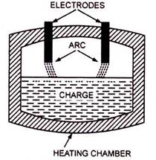

**Merits:**

It produces purer products, when compared with other methods.

It is very simple and easy to control the composition of the final product during refining process.

**Demerits:**

It is very costlier.

Electric energy is expensive, Even though it is used for both smelting and refining.

**Application:**

This type of furnace is to produce steel, alloy steel such as stainless steel etc.

Used for the manufacture of gray iron casting.

### INDIRECT ARC FURNACE

In indirect arc furnace, the arc strikes between two electrodes by bringing momentarily in contact and then with drawing them heat so developed, due to the striking of arc across air gap is transferred to charge is purely by radiation.

These furnaces are usually l-Φ and hence their size is limited by the amount of one- phase load which can be taken from one point.

Since on this furnace current does not flow through the charge, there is no stirring action and the furnace is required to be rocked mechanically.

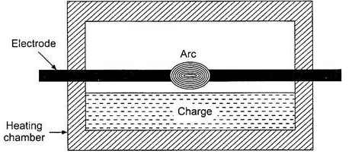

* 1. The electrodes are projected through this chamber at each end along the horizontal axis. This furnace is also sometimes called as rocking arc furnace.
  2. The charge in this furnace is heated not only by radiation from the arc between electrode tips but also by conduction from the heated refractory during rocking action; so, the efficiency of such furnace is high.
  3. Power input to the furnace is regulated by adjusting the arc length by moving the electrodes.
  4. Even though it can be used in iron foundries where small quantities of iron are required frequently, the main application of this furnace is the melting of non-ferrous metals.

**Advantages:**

1. Lower overall production cost per tonne of molten material.
2. Sound casting in thin and intricate design can be produced.
3. Metal losses due to oxidation and volatilization are quite low.
4. Flexible in operation.

**Disadvantages:**

1. No inherent stirring action as there is no current flow through the charge.
2. Continuous rocking should be done to distribute heat uniformly.

**Application:**

1. The main application of this type furnace is melting of non-ferrous metals.

# INDUCTION HEATING

Induction heating is based on the principle of transformers. There is a primary winding through which an AC current is passed.

The coil is magnetically coupled with the metal to be heated which acts as secondary. An electric current is induced in this metal when the AC current is passed through the primary coil.

**Types of induction furnaces:**

* + - 1. Core type (low frequency) induction furnaces.
      2. Coreless type (high frequency) induction furnaces.

**1.Core type furnaces:** They operate similar to a two winding transformer.

They are classified into three types. They are

1. Direct core type

2. Vertical core type

3. Indirect core type.

### (a) Direct core type induction furnace

* 1. The core type furnace is essentially a transformer in which the charge to be heated forms single turn secondary circuit and is magnetically coupled to the primary by an iron core.
  2. The furnace consists of a circular hearth in the form of a trough, which contains the charge to be melted in the form of an annular ring.

1. This type of furnace has the following characteristics:
   * + This metal ring is quite large in diameter and is magnetically interlinked with primary winding, which is energized from an AC source. The magnetic coupling between primary and secondary is very weak; it results in high leakage reactance and low pf. To overcome the increase in leakage reactance, the furnace should be operated at low frequency of the order of 10 Hz.

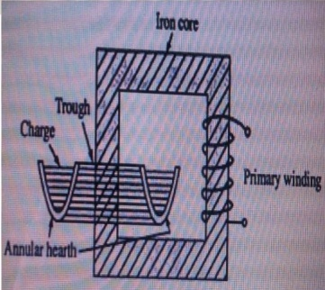

**Figure:Direct Core Type Induction Furnace**

1. When there is no molten metal in the hearth, the secondary becomes open circuited thereby cutting of secondary current. Hence, to start the furnace, the molten metal has to be taken in the hearth to keep the secondary as short circuit.
2. Furnace is operating at normal frequency, which causes turbulence and severe stirring action in the molten metal to avoid this difficulty, it is also necessary to operate the furnace at low frequency.
3. In order to obtain low-frequency supply, separate motor-generator set (or) frequency changer is to be provided, which involves the extra cost.
4. The crucible used for the charge is of odd shape and inconvenient from the metallurgical viewpoint.
5. If current density exceeds about 500 A/cm2, it will produce high-electromagnetic forces in the molten metal and hence adjacent molecules repel each other, as they are in the same direction.
6. The repulsion may cause the interruption of secondary circuit (formation of bubbles and voids); this effect is known as pinch effect.

The pinch effect is also dependent on frequency; at low frequency, this effect is negligible, and so it is necessary to operate the furnace at low frequency.

### Vertical core type induction furnace

### 

*Figure. Ajax-Wyatt Induction Furnace (Vertical Core Type Induction Furnace)*

It is an improvement over the direct core type furnace, to overcome some of the disadvantages mentioned in direct core type induction furnace. This type of furnace consists of a vertical core instead of horizontal core. It is also known as Ajax-Wyatt induction furnace.

Vertical core avoids the pinch effect due to the weight of the charge in the main body of the crucible.

The leakage reactance is comparatively low and the power factor is high as the magnetic coupling is high compared to direct core type.

There is a tendency of molten metal to accumulate at the bottom that keeps the secondary completed for a vertical core type furnace as it consists of narrow V-shaped channel.

The inside layer of furnace is lined depending upon the type charge used. Clay lining is used for yellow brass and an alloy of magnesia and alumina is used for red brass.

The top surface of the furnace is covered with insulating material, which can be removed for admitting the charge.

Necessary hydraulic arrangements are usually made for tilting the furnace to take out the molten metal. Even though it is having complicated construction, it is operating at power factor of the order of 0.8-0.83.

This furnace is normally used for the melting and refining of brass and nonferrous metals.

**Advantages:**

Accurate temperature control and reduced metal losses.

Absence of crucibles.

Consistent performance and simple control.

It is operating at high power factor.

Pinch effect can be avoided.

### (c ) Indirect core type furnace

This type of furnace is used for providing heat treatment to metal.

The secondary winding itself forms the walls of the container or furnace and an iron core links both primary and secondary windings.

The heat produced in the secondary winding is transmitted to the charge by radiation.

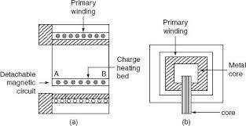

*Figure Indirect Core Type Induction Furnace*

### 2.Coreless type induction furnace

It is a simple furnace with the absence of core. In this furnace, heat developed in the charge due to eddy currents flowing through it. The furnace consists of a refractory or ceramic crucible cylindrical in shape enclosed within a coil that forms primary of the transformer.

The furnace also contains a conducting or non-conducting container that acts as secondary. If the container is made up of conducting material, charge can be conducting or non-conducting; whereas, if the container is made up of non-conducting material, charge taken should have conducting properties.

When primary coils are excited by an alternating source, the flux set up by these coils induce the eddy currents in the charge. The direction of the resultant eddy current is in a direction opposite to the current in the primary coil.

These currents heat the charge to melting point and they also set up electromagnetic forces that produce a stirring action to the charge.

The eddy currents developed in any magnetic circuit are given as:

We α Bm2f2

Where,

Bm is the maximum flux density (Tesla),

f is the frequency in (Hz) and

We is the eddy current loss (Watts).

In coreless furnace, the flux density will be low as there is no core. Hence, the primary supply should have high frequency for compensating the low flux density.

If it is operating at high frequency, due to the skin effect, it results copper loss, thereby increasing the temperature of the primary winding.

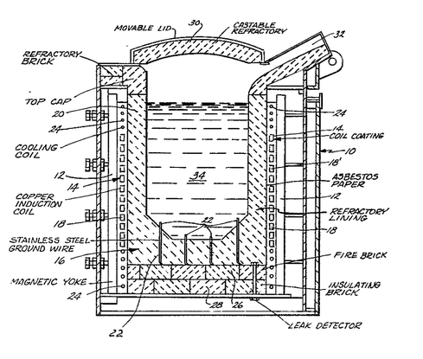

This necessitates in artificial cooling. The coil, therefore, is made of hollow copper tube through which cold water is circulated.

Minimum stray magnetic field is maintained when designing coreless furnace, otherwise there will be considerable eddy current loss.

**Following are the advantages of coreless furnace over the other furnaces:**

1. Ease of control.
2. Oxidation is reduced, as the time taken to reach the melting temperature is less.
3. The eddy currents in the charge itself results in automatic stirring.
4. The cost is less for the erection and operation.
5. It can be used for heating and melting.
6. Any shape of crucible can be used.
7. It is suitable for intermittent operation.

# DIELECTRIC HEATING

Dielectric heating is also sometimes called as high frequency capacitance heating. If non metallic materials i.e., insulators such as wood, plastics, china clay, glass, ceramics etc are subjected to high voltage AC current, their temperature will increase due to the conversion of dielectric loss into heat.

The supply frequency required for dielectric heating is between 10-50 MHz and applied voltage is 20 kV.

The overall efficiency of dielectric heating is about 50%.

When a capacitor is subjected to a sinusoidal voltage, the current drawn by it is never leading the voltage by exactly 90°. The angle between the current and the voltage is slightly less with the result that there is a small in-phase component of the current which produces power loss in the dielectric of the capacitor.

At ordinary frequency of 50 Hz such loss may be small enough to be negligible but at high frequencies the loss becomes large enough to heat the dielectric. It is this loss that is utilized in heating the dielectric.

The insulating material is placed in between two conducting plates in order to form a parallel plate capacitor shown in figure.

The dielectric loss is dependent upon the frequency and high voltage. Therefore for obtaining high heating effect high voltage at high frequency is usually employed.

The charge to be heated is placed between two sheet type electrodes which form a capacitor.

Power drawn from supply, *P = VIcosΦ*

Now, *Ic = I = V/Xc = 2ΠfCV*

*P = V(2ΠfCV) cosΦ = 2ΠfCV2cosΦ*

Now, *Φ = (90°-δ)*

*cosΦ = cos(90°-δ)*

*= sinδ = tanδ =δ.* If *δ* is assumed to be very small.

*P = 2ΠfCV2δ*

Here*C=єoєrA/t*

Where, *t* - thickness of the dielectric slab

*A* - area of the dielectric slab

*єr* is the relative permittivity

*єo* is the absolute permittivity of the vacuum (= 8.854 x 10-12 F/m).

This power is converted into heat. Since for a given insulation material C and δ are constant, the dielectric loss α V2f.

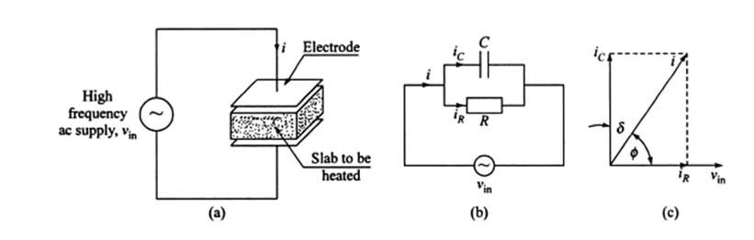

**Advantages:**

1. Uniform heating is obtained.
2. Running cost is low.
3. Non conducting materials are heated within a short period.
4. Easy heat control.
5. With increase in frequency the heating becomes faster.
6. Inflammable articles like plastics and wooden products can be safely heated.

**Disadvantages:**

* 1. High installation cost. So preferred where other methods are not possible.

**Applications:**

* 1. Food processing.
  2. Wood processing.
  3. Drying purpose in textile industry.
  4. Electronic sewing.
  5. Dehydration of foods.
  6. Vulcanizing of rubber.
  7. Drying of explosives.
  8. Heating of tissues and bones of body required for the treatment of certain types of pains and diseases.
  9. Removal of moisture from oil.